MLL 102 TUTORIAL 1

GROUP-1

NAME ENTRY NO.

SATYAM SHARMA 2023MS10199

MANAS MISHRA 2023MS10107

MUSKAN 2023MS10266

SHUBHI JAIN 2023MS10180

AVIRAL AKSHAT 2023MS11098

ASHUTOSH SAHU 2023MS101089

1.

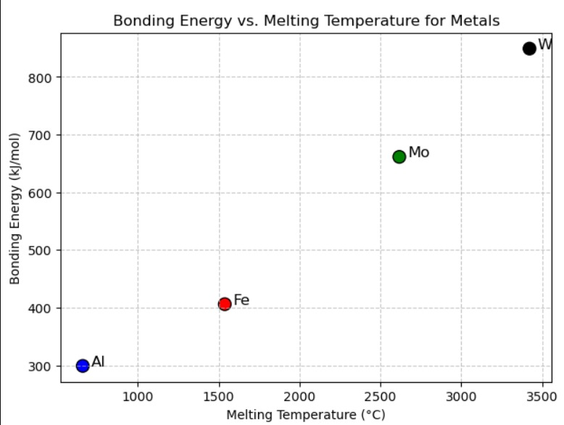

The estimated bonding energy for molybdenum (Mo) with a melting temperature of 2617°C is approximately 661 kJ/mol

3.

